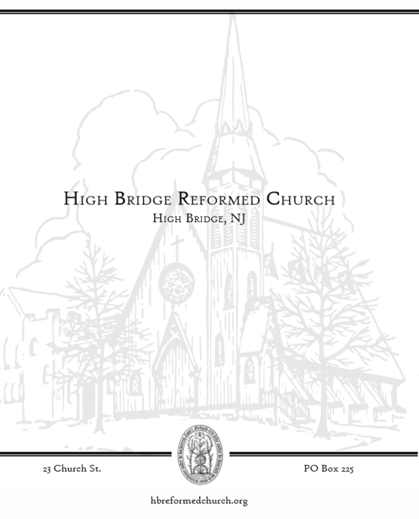

WELCOME!
To all who worship with us this morning: we rejoice that you are here. May God’s Spirit warm our hearts, stir our faith, renew our strength, and refresh our hope. If this is your first time in worship or you are interested in more information, please sign the guest book in the back of the Sanctuary. We look forward to being in touch! NOTES FOR WORSHIP Meaning of Symbols * Please stand if you are able. + Denotes elements led by the Liturgist ~ Denotes elements shared by Liturgist & Pastor Bolded text is spoken by all who are in worship.

NOTES FOR WORSHIP

Please sign the attendance sheet located in the back when you have a moment before or after service today.
Please remember to fill out a prayer request card if you have anyone you would like to lift up this week.

Meaning of Symbols in the Bulletin
* Please stand if you are able.
Bolded text is spoken by all who are in worship.

Children in Worship
We love kids and welcome all their wiggles and giggles--it is the sound of life! Children learn best by imitation and play, therefore it is vital they be in worship and see adults modeling their faith. We offer a brief “message for all ages” for our children. In the foyer at the back right of the Sanctuary there are children’s bags in a basket on the bookshelf. Your children are welcome to get up and move around as need be.

Assisting in Worship This Morning:
Music Director: Landon Peer

ORDER OF WORSHIP

Sunday, June 26, 2022
Scarlet Gorton

GOD GATHERS THE CHURCH

PRELUDE
WELCOME
VOTUM
One: Our help is in the name of the Lord who made heaven and earth.
All: Amen.

CALL TO WORSHIP

One: Jesus our Lord is risen.
ALL: Lord, may we experience the power of your resurrection and live by it.

One: The call of freedom has been sounded.
ALL: Lord, may we respond as the community of the free.

One: It concerns every one of us personally, in our place, in our humanity, in this world.
ALL: Lord, may we live by the Spirit and not live to gratify our sinful desires.

SALUTATION
One: Grace to you, and peace, from God our Father, and the Lord Jesus Christ.
All: Amen

*HYMN #793 For the Beauty of the Earth v. 1,3,4

CALL TO CONFESSION

PRAYER OF CONFESSION (unison)
All: Almighty God, we acknowledge and confess that we have sinned against you in thought, word, and deed; we have not loved you with all of our heart, soul, mind, and strength; we have not loved our neighbor as ourselves. Deepen within us our sorrow for the wrong we have done, and the good we have left undone. Lord, you are full of compassion and gracious, slow to anger, and full of mercy; there is always forgiveness with you! Restore to us the joy of your salvation; bind up that which is broken, give light to our minds, strength to our wills, and rest to our souls. Speak to each of us, and let your word abide with us until it has formed in us your holy will. Amen.

A silence is kept for personal reflection

WORDS OF ASSURANCE

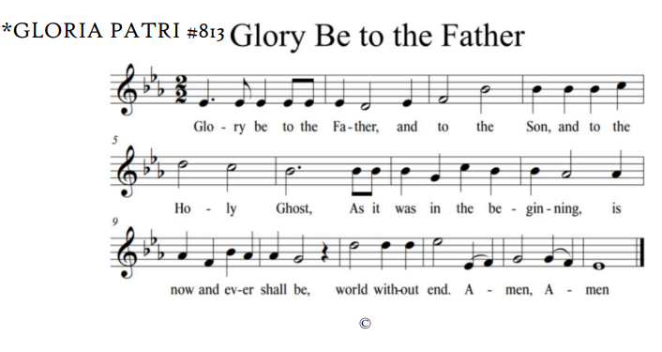

GOD’S WORD IS PROCLAIMED

MESSAGE FOR CHILDREN OF ALL AGES

*CHRISTIAN GREETING
One: The peace of Christ be with you
All: And also with you!

PRAYER OF ILLUMINATION

SCRIPTURE READING
2 Kings 2:1-2, 5-14
Galatians 5:1, 13-25

One: This is the Word of the Lord
All: Thanks be to God.

SERMON “Freedom and Power to Love and Serve”

OUR RESPONSE TO GOD

AFFIRMATION OF FAITH: APOSTLES CREED
All:
I believe in God the Father almighty, maker of heaven and earth;
And in Jesus Christ, his only Son, our Lord;
who was conceived by the Holy Spirit,
born of the virgin Mary,
suffered under Pontius Pilate,
was crucified, dead, and buried.
He descended into hell.
The third day he rose again from the dead.
He ascended into heaven,
and sitteth on the right hand of God the Father almighty.
From thence he shall come to judge the quick and the dead.
I believe in the Holy Spirit,
the holy catholic church,
the communion of saints,
the forgiveness of sins,
the resurrection of the body,
and the life everlasting. Amen.”

*HYMN #551 O to Be like Thee!

RECEPTION OF OUR GIFTS AND OFFERINGS

*THE DOXOLOGY #815
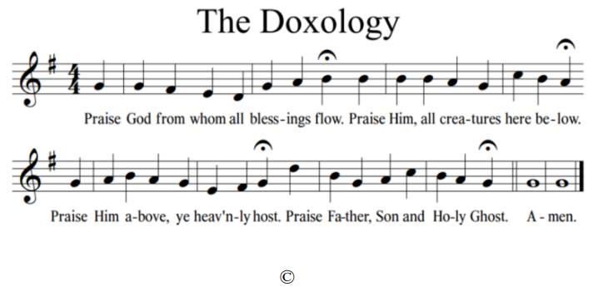

PRAYERS OF THE PEOPLE & THE LORD’S PRAYER
One …We pray all these things in the name of Jesus, who taught us to pray and prays with us saying:
All: [Lord’s Prayer]
Our Father, who art in heaven, hallowed be thy name, thy kingdom come, thy will be done, on earth as it is in heaven. Give us this day our daily bread. And forgive us our debts, as we forgive our debtors. And lead us not into temptation, but deliver us from evil. For thine is the kingdom, and the power, and the glory, forever. Amen.

*HYMN #669 Make Me a Servant

BENEDICTION

*POSTLUDE

OUR LIFE TOGETHER

- Interested in Bible Study?
Please see the insert for Wednesday Night Bible Study details. Sign up on the sheet in the back of Church or reach out to Pastor Scarlet if interesting in joining.

- Consistory meeting will be Tuesday August 16, 2022.

- A copy of all approved 2022 Consistory Minutes and Financial Reports has been placed in a red binder in the foyer. Please do not remove anything from the binder. If you would like a copy of your own, please see Jessica.

- Our Classis (AKA the organization of pastors and elders that governs our regional group of local churches) has asked that we spend time in prayer for a fellow church each week. We invite you to add the church of the week to your prayers. This week, please pray for all Reformed Churches. We pray for the congregations’ health and wellness in mind, body and spirit.

