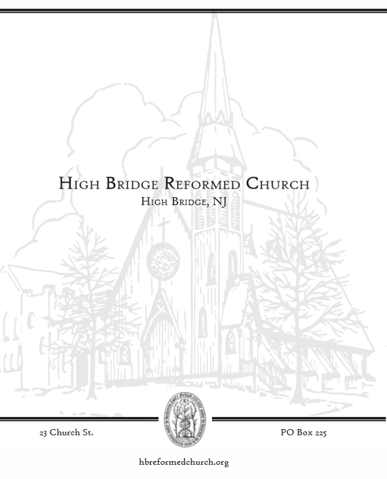

WELCOME!
To all who worship with us this morning: we rejoice that you are here. May God’s Spirit warm our hearts, stir our faith, renew our strength, and refresh our hope. If this is your first time in worship or you are interested in more information, please sign the guest book in the back of the Sanctuary. We look forward to being in touch! NOTES FOR WORSHIP Meaning of Symbols * Please stand if you are able. + Denotes elements led by the Liturgist ~ Denotes elements shared by Liturgist & Pastor Bolded text is spoken by all who are in worship.

NOTES FOR WORSHIP

Please sign the attendance sheet located in the back when you have a moment before or after service today.
Please remember to fill out a prayer request card if you have anyone you would like to lift up this week.

Meaning of Symbols in the Bulletin
* Please stand if you are able.
Bolded text is spoken by all who are in worship.

Children in Worship
We love kids and welcome all their wiggles and giggles--it is the sound of life! Children learn best by imitation and play, therefore it is vital they be in worship and see adults modeling their faith. We offer a brief “message for all ages” for our children. In the foyer at the back right of the Sanctuary there are children’s bags in a basket on the bookshelf. Your children are welcome to get up and move around as need be.

Assisting in Worship This Morning:
Music Director: Landon Peer

ORDER OF WORSHIP
2nd Sunday of Epiphany
Sunday, January 15, 2023
Pastor Ed Staats

GOD GATHERS THE CHURCH

PRELUDE
WELCOME
VOTUM

Leader: Our help is in the name of the Lord who made heaven and earth.
People: Amen.

CALL TO WORSHIP

Leader: In Christ, the God of heaven has made his home on earth.
People: Christ dwells among us and is one with us.

Leader: Highest of all creation, he lives among the least.
People: He journeys with the rejected and welcomes the weary.

Leader: Come now, all who thirst, and drink of the water of life.
People: Come now, all who hunger, and be filled with good things.

Leader: Come now, all who seek,
People: Come and encounter the abundant love of the almighty God.

SALUTATION

Leader: Grace to you, and peace, from God our Father, and the Lord Jesus Christ.
People: Amen

*HYMN #293 Praise the One who Breaks the Darkness

CALL TO CONFESSION

PRAYER OF CONFESSION (unison)

People: All-knowing God, we come to you this day knowing we have sinned. We have sought after possessions that would please us, but we know our happiness is only temporary. We have sought to worship idols of laziness, luxury, and prestige. We have sought power over others at their expense, yet we have not found the happiness we were seeking. Remind us again that we must choose life and not death, we must choose you over what others tempt us to do and to be. We must choose forgiveness over harboring grudges and hate. Deliver us from temptation and evil this day. In the name of Jesus Christ, we pray. Amen.
A silence is kept for personal reflection

WORDS OF ASSURANCE Joel 2:12-13

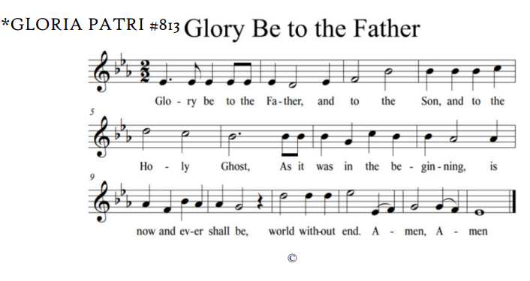
GOD’S WORD IS PROCLAIMED

MESSAGE FOR CHILDREN OF ALL AGES

*CHRISTIAN GREETING
Leader: The peace of Christ be with you
People: And also with you!

SCRIPTURE READING

Luke 3:7-9 & 15-22

Leader: This is the Word of the Lord
People: Thanks be to God.

SERMON “…With You I am Well Pleased.”

OUR RESPONSE TO GOD

AFFIRMATION OF FAITH: APOSTLES CREED
All:
I believe in God the Father almighty, maker of heaven and earth;
And in Jesus Christ, his only Son, our Lord;
who was conceived by the Holy Spirit,
born of the virgin Mary,
suffered under Pontius Pilate,
was crucified, dead, and buried.
He descended into hell.
The third day he rose again from the dead.
He ascended into heaven,
and sitteth on the right hand of God the Father almighty.
From thence he shall come to judge the quick and the dead.
I believe in the Holy Spirit,
the holy catholic church,
the communion of saints,
the forgiveness of sins,
the resurrection of the body,
and the life everlasting. Amen.”

*HYMN # 467 Come Holy Spirit, Dove Divine

RECEPTION OF OUR GIFTS AND OFFERINGS

*THE DOXOLOGY #815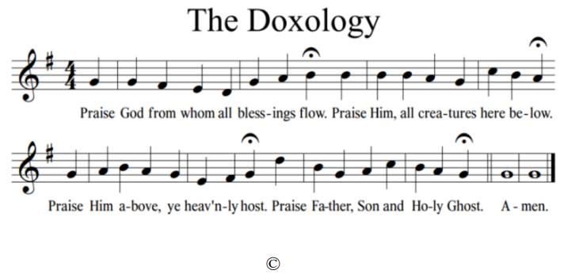

PRAYERS OF THE PEOPLE & THE LORD’S PRAYER
Leader …We pray all these things in the name of Jesus, who taught us to pray and prays with us saying:

People: [Lord’s Prayer]
Our Father, who art in heaven, hallowed be thy name, thy kingdom come, thy will be done, on earth as it is in heaven. Give us this day our daily bread. And forgive us our debts, as we forgive our debtors. And lead us not into temptation, but deliver us from evil. For thine is the kingdom, and the power, and the glory, forever. Amen.

*HYMN #308 There is a Redeemer

BENEDICTION

CHORAL BENEDICTION #584 God Be With You (verse 1)

*POSTLUDE

OUR LIFE TOGETHER
- Happy Birthday Audrey (1/19)!

- Our Congregational meeting will be held TODAY immediately following worship in the Fellowship Hall during Coffee Hour.

- We are restarting the prayer chain. If you would like to be added to the chain please see Susan or sign up in the back.

- Consistory meeting will be Wednesday January 18, 2022.

- 2023 Offering Envelopes have been given out. If you do not have envelopes and would like them, please see Jessica.

- Our Classis (AKA the organization of pastors and elders that governs our regional group of local churches) has asked that we spend time in prayer for a fellow church each week. We invite you to add the church of the week to your prayers. This week, please pray for all Reformed Churches in our Classis. We pray for the congregations’ health and wellness in mind, body and spirit.

